**Exploratory Data Analysis (EDA) Project - Telecom Customer Churn**

**Introduction**

This project performs **Exploratory Data Analysis (EDA)** on a **telecom customer churn dataset** to understand customer retention, service usage, and key factors influencing churn rates. The analysis helps in identifying patterns and trends that affect customer decisions, allowing businesses to take strategic actions.

**Goals of the Project**

* Explore the telecom dataset using Pandas and NumPy.
* Perform data cleaning and feature engineering.
* Analyse customer churn rates using statistical methods.
* Visualize key insights using Seaborn and Matplotlib.
* Identify factors affecting customer churn.

**Materials and Methods**

**Dataset Overview**

The dataset consists of telecom customer records, including attributes such as contract details, payment methods, and usage statistics. Key columns include:

* **Customer Information**: customerID, gender, SeniorCitizen, Partner, Dependents
* **Service Information**: PhoneService, InternetService, StreamingTV, OnlineSecurity
* **Billing Information**: MonthlyCharges, TotalCharges, PaymentMethod
* **Churn Indicator**: Churn (whether the customer left or stayed)

**Libraries Used:**

import pandas as pd

import numpy as np

import seaborn as sns

import matplotlib.pyplot as plt

**Key Insights & Findings:**

* **Contract Type and Churn:**
  + Customers on **month-to-month contracts** exhibit the highest churn rate, with

**42%** of such customers likely to churn.

* + In contrast, customers on **one-year** and **two-year contracts** have churn rates of

**11%** and **3%**, respectively.

* + **Implication:** Longer contract periods serve as a strong retention tool, as customers with extended commitments are far less likely to leave.
* **Payment Methods and Churn:**
  + Customers paying via **electronic checks** show the highest churn rate at **45%**, while those using **credit cards, bank transfers, or mailed checks** have significantly lower churn rates, averaging around **15-18%**.
  + **Implication:** The convenience, security, and trust issues related to electronic payments might be contributing factors. Encouraging customers to switch to more stable payment methods could reduce churn.
* **Churn by Tenure:**
  + Customers with **less than one year** of tenure are the most likely to churn, with a **50%** churn rate. Those with **1-3 years of tenure** show a decreasing churn trend at **35%**, while customers who have been with the company for **more than three years** have a churn rate of just **15%**.
  + **Implication:** Engaging customers early in their journey, especially within the first year, is critical for retention.
* **Churn by Internet Service Type:**
  + Customers using **Fiber Optic** services show a higher churn rate of **30%**, compared to **DSL customers** with a churn rate of **20%**.
  + **Implication:** This could be due to increased competition or dissatisfaction with service quality. Understanding customer satisfaction with service speed and reliability may help retain fiber optic users.
* **Senior Citizens and Churn:**
  + The analysis reveals that **senior citizens** (aged 65+) have a churn rate of **41%**, compared to a **26%** churn rate among non-senior citizens.
  + **Implication:** Special retention programs and targeted customer service for senior customers may help reduce churn in this demographic.

**Visualizations & Data Insights:**

* **Bar Charts and Line Graphs:**
  + The visual representation of churn by **payment method** clearly shows that customers using electronic checks churn almost three times as much as those using more traditional or secure methods like credit cards.
  + **Customer tenure** vs. churn rate visualizations reveal a clear declining trend in churn as customers' tenure increases, underscoring the need for early-stage customer loyalty programs.
* **Percentage Distribution of Churn Across Factors:**
  + **Payment Methods:** 45% churn for electronic check users, 15% for credit card users.
  + **Contract Types:** 42% churn for month-to-month contracts, 11% for yearly contracts, 3% for two-year contracts.
  + **Tenure:** 50% churn in the first year, dropping to 15% after three years.

.

1. **What insights are gained from the customer churn analysis?**  
   **Answer:**

* **Overall Churn Rate:** About **26.54%** of customers have churned.
* **Senior Citizens:** A **higher percentage** of senior citizens have churned compared to younger customers.
* **Tenure vs Churn:** Customers with shorter tenure (1-2 months) have a **higher churn rate**, while long-term users tend to stay.
* **Contract Type:** Customers with **month-to-month contracts** are **more likely to churn** compared to those with 1-year or 2-year contracts.
* **Payment Method:** Customers using **Electronic Checks** have the highest churn rate.
* **Paperless Billing:** Customers **without paperless billing** are more likely to churn.

1. **What does the histogram of tenure tell us about customer churn?**  
   **Answer:**  
   The histogram shows that customers with very short tenure (1-2 months) **churn at a much higher rate**, while customers who have used the service for a longer time tend to stay.
2. **What is the trend in churn based on contract type?**  
   **Answer:**

* Customers with **month-to-month contracts** churn more frequently.
* Customers with **1-year or 2-year contracts** have lower churn rates.
* This suggests that **long-term contracts help in retaining customers**.

1. **How can telecom companies reduce churn based on this analysis?**  
   **Answer:**

* Offer **long-term contract discounts** to prevent month-to-month cancellations.
* Improve **services for senior citizens**, as they churn at higher rates.
* Provide incentives for customers **using electronic checks** to switch to other payment methods.
* Encourage **paperless billing**, as those not using it have a higher churn rate.
* Offer **customer support** and **discounts for new users** to retain short-tenure customers.

1. **Which customer services impact churn the most?**  
   **Answer:**

* Customers with **no tech support**, **no online security**, or **no backup services** have a **higher churn rate**.
* Customers using **DSL Internet Service** churn less compared to those using fibre optics.

**Conclusion:**

* Customers with short tenure and **month-to-month contracts** should be targeted for retention.
* Offering **loyalty incentives** for long-term contracts can reduce churn.
* Encouraging **bundled services (e.g., Online Security, Tech Support)** can improve retention.
* Implement customer segmentation for **targeted marketing campaigns**.
* Further analysis using **predictive modelling (e.g., logistic regression, decision trees)** to anticipate churn.

**Visualizations:**

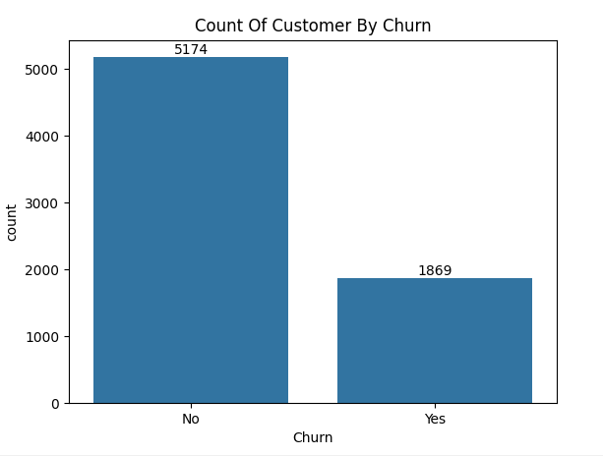

Fig1: Count Of Customer Churned

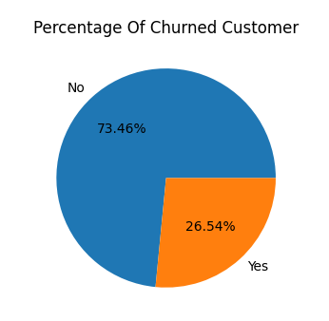

Fig2: Percentage Of Customer Churn

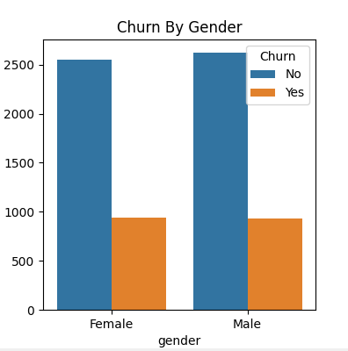

Fig3: Churned By Gender

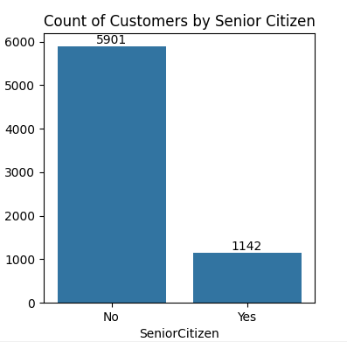

Fig4:Churned By Senior Citizen

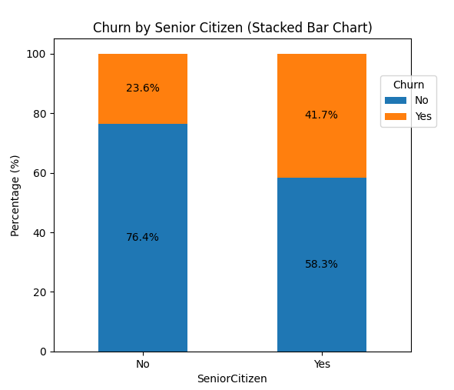

Fig5: Churned By Senior Citizen (Stacked Bar Chart)

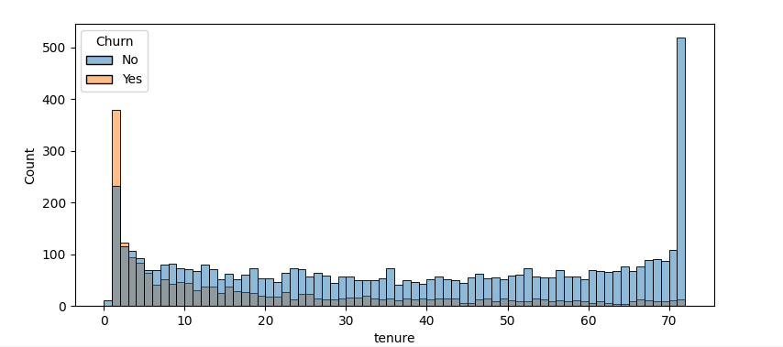

Fig6: Tenure Churn Count

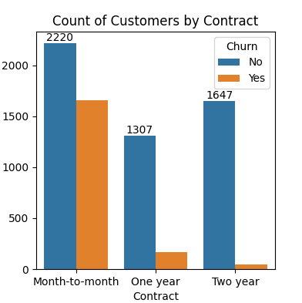

Fig7: Count Of Customer Churn by Contract

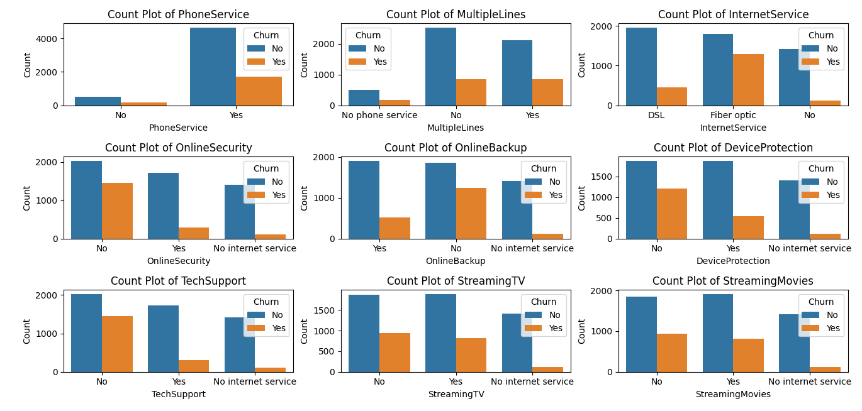

Fig8: Count Base on Services

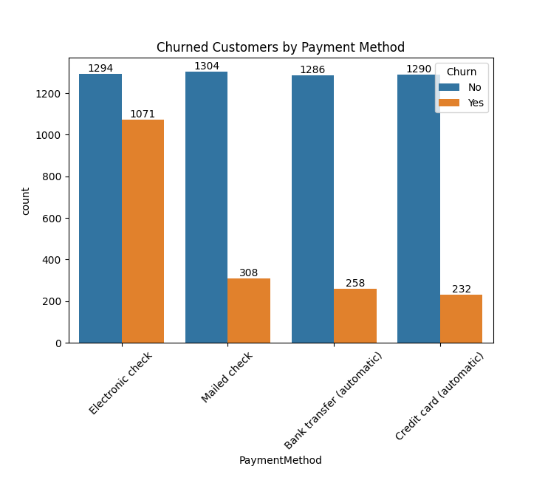

Fig9: Churned Customer By Payment Method

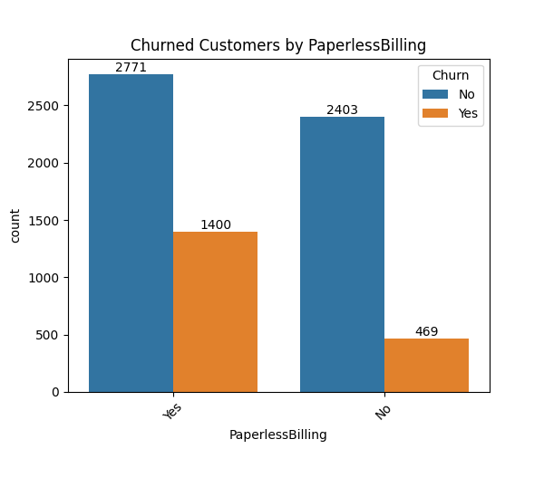

Fig10: Churned Customer Biling mode